EXPERIMENT : 1

NAME : HARISARAN.A ROLL NO : 240701170

Design Experiment: “Hell’s Hoodies” Promotional Poster
This design experiment focuses on creating a bold and eye-catching promotional poster for a hoodie brand called “Hell’s Hoodies.” The main objective was to attract young customers and clearly communicate a limited-time discount offer while showcasing the products.

Concept
The concept of the design is modern streetwear promotion. The name “Hell’s Hoodies” suggests a strong, edgy identity, so the design uses bold colors, playful typography, and dynamic shapes to reflect a trendy street-fashion vibe.

Color Experiment
Three contrasting background colors were used:
- Coral red – creates strong visual energy and grabs attention.
- Soft yellow – highlights the center product and gives warmth.
- Teal green – adds balance and a modern aesthetic.
These curved color sections were experimented with to separate the layout visually while keeping the design smooth and stylish.
Typography Choice
The title “hell’s hoodies” uses a decorative serif font to create a distinct brand identity.
The discount badge “25% OFF” uses bold, playful lettering to instantly catch the viewer’s eye.

Product Placement
Two hoodies were placed in the center area:
- Yellow hoodie – placed in the middle to become the main focus.
- Green hoodie – positioned on the right to show product variety.
This arrangement was experimented with to create visual balance and clear product visibility.

Promotional Element
A starburst badge with “25% OFF” was added on the left side. This shape was chosen because it naturally draws attention and emphasizes the promotional offer.

Information Section
The store address “55, Hell Street, Chennai 605118” is placed at the bottom to provide location details while keeping the focus on the products and discount.

Conclusion
This experiment demonstrates how color contrast, typography, and product placement can work together to create an attractive promotional poster. The final design successfully highlights the brand identity, showcases the hoodies, and communicates the discount offer effectively.

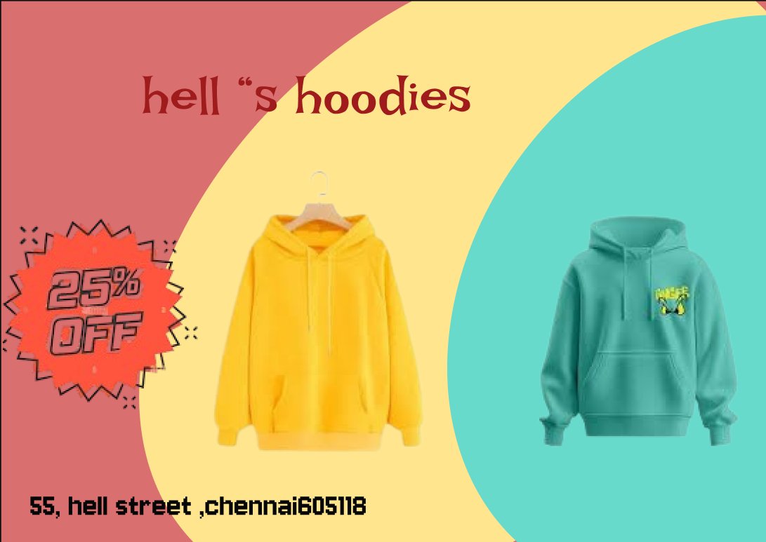

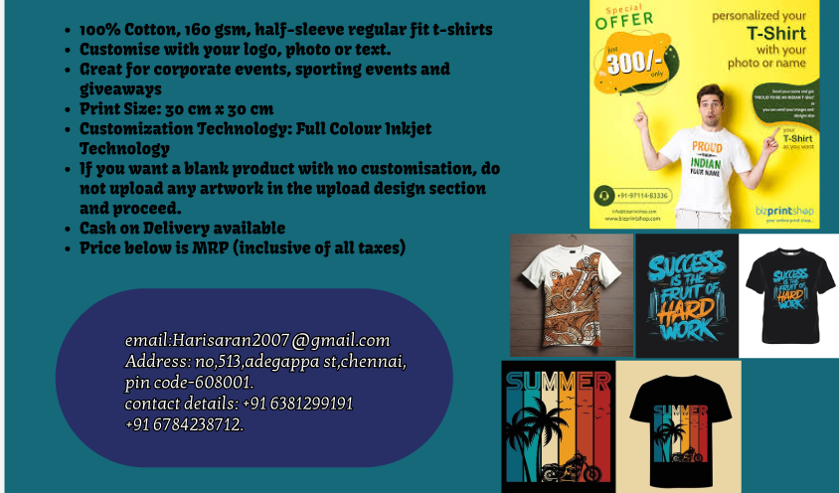

Link:
https://www.figma.com/design/9hkgK4205A7C5hxCQYd51F/Untitled?t=asSDki2MnmjedDSL-1

